“DBMS LAB FILES”

SUBMITTED BY
NAME = Jitendra Rajendra Shinde.
PRN=2124UCSM1005

{Data Base Management System }
UnDEr ThE GUIDAncE oF
MR. Utkarsh Varshney Sir


Department of
“Computer Science and Engineering”
SAnjIvAnI rUrAL EDUcATIon SocIETY
SAnjIvAnI UnIvErSITY
KoPArGAon – 423603,
DIST : AhMEDnAGAr 2024-25

INDEX

Sr.  No. | Practical Title | Date | Signature | Page No.
1 | Install and Set Up MySQL. Create Database and Table for Employee Details. Perform INSERT & DELETE.
2 | Create Student Table. Perform INSERT,  UPDATE, DELETE, and SELECT Operations.
3 | Create Employee Table with Data Types.  Insert Data and Perform Queries.
4 | Create Employee Table with Constraints (Primary Key, Foreign Key, Unique). Test with Valid/Invalid Data.
5 | Create Customer Table with NOT NULL, CHECK, DEFAULT Constraints. Test with Valid/Invalid Data.
6 | Use DDL and DML Commands. Perform Insert,  Update, Delete, and Data Retrieval Using SELECT Queries.
7 | Create Sales Table. Use Aggregate  Functions: COUNT, SUM, AVG, MIN, MAX.
8 | Use INNER JOIN, LEFT JOIN, and RIGHT JOIN on Customers and Orders Tables.

Lab File – Practical 1

AIM :- Install and set up MySQL. Create a database and a table to store employee details.

• CODE FOR INSERTION :-

CREATE DATABASE PRACTICAL1;
USE PRACTICAL1;
CREATE TABLE EMPLOYEE(
id int auto_increment primary key,
name varchar(50) not null,
departement varchar(50) not null,
position varchar(50) not null,
salary decimal(10,2),
joindate date not null);
insert into EMPLOYEE (name, departement, position, salary, joindate)
VALUES
('Jitendra', 'COMPUTER', 'MANAGER', '10000.00', '2020-03-04'),
('ALEX', 'CYBER', 'MANAGER', '10000.00', '2020-03-04'),
('ROBIN', 'COMPUTER', 'EMPLOYEE', '1000.00', '2024-01-12'),
('ROCKEY', 'COMPUTER', 'EMPLOYEE', '1000.00', '2023-06-14'),
('KAILY', 'CYBER', 'EMPLOYEE', '1000.00', '2020-03-04');

select * from EMPLOYEE;

- Output :

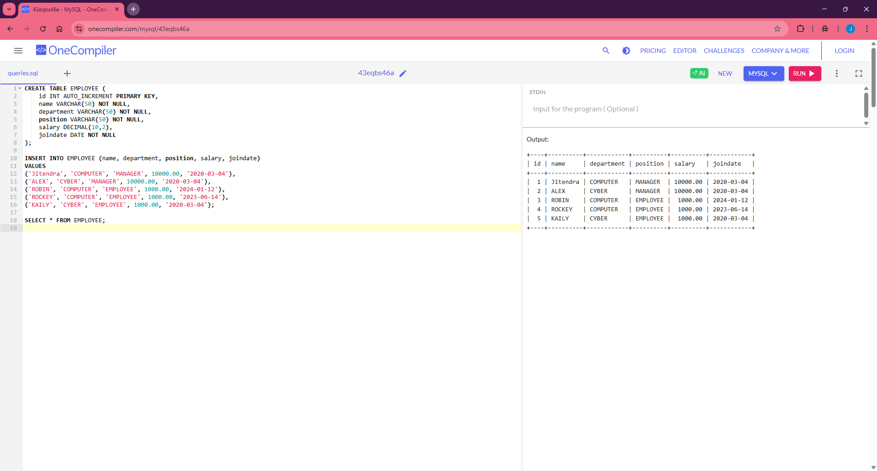

- CODE FOR DELETION :- CREATE TABLE EMPLOYEE

id int auto_increment primary key,
name varchar(50) not null,
departement varchar(50) not null,
position varchar(50) not null,
salary decimal(10,2),
joindate date not null);
insert into EMPLOYEE (name, departement, position, salary, joindate)
VALUES
(jitendra', 'COMPUTER', 'MANAGER', '10000.00', '2020-03-04'),
('ALEX', 'CYBER', 'MANAGER', '10000.00', '2020-03-04'),
('ROBIN', 'COMPUTER', 'EMPLOYEE', '1000.00', '2024-01-12'),
('ROCKEY', 'COMPUTER', 'EMPLOYEE', '1000.00', '2023-06-14'),
('KAILY', 'CYBER', 'EMPLOYEE', '1000.00', '2020-03-04');

DELETE FROM EMPLOYEE WHERE id = 4;
select * from EMPLOYEE;

Output:

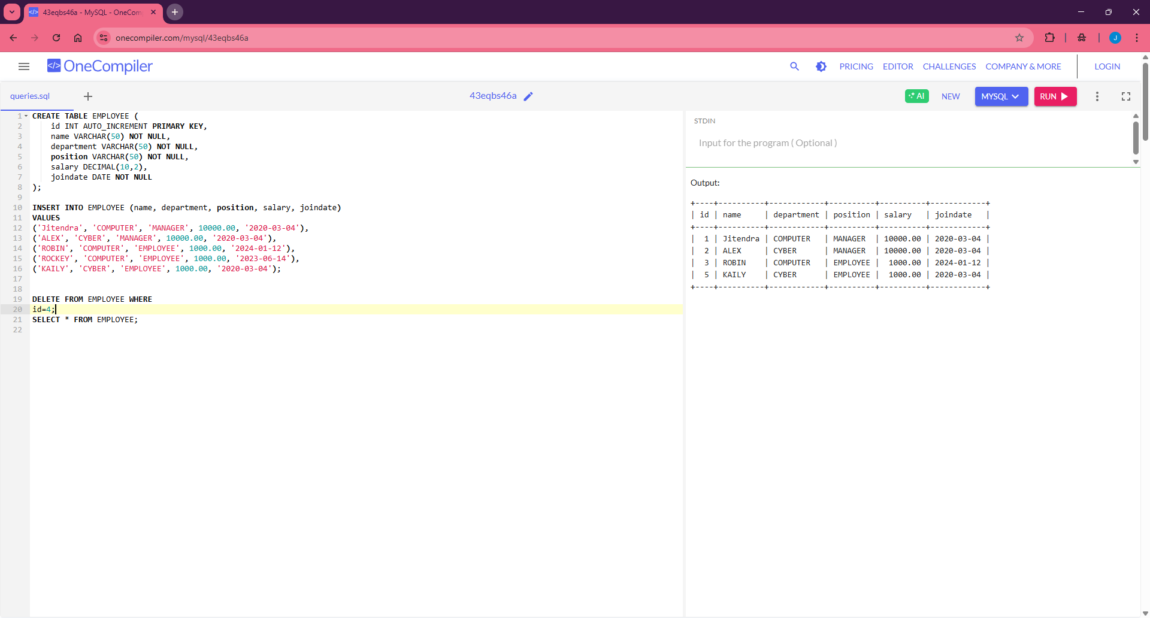

Lab File – Practical 2

Aim: Create a table for storing student information. Insert sample data and perform basic Operations: INSERT, UPDATE, DELETE, and SELECT.

- CODE FOR TABLE CREATION :-

CREATE DATABASE PRACTICAL2;
USE PRACTICAL2;
CREATE TABLE STUDENTS_INFO(
STUDENT_ID int auto_increment primary key,
STUDENT_NAME varchar(50) not null,
STUDENT_MAIL_ID varchar(50) not null,
DEPARTMANT varchar(50) not null, JOIN_DATE date not null);

SELECT * FROM STUDENTS_INFO

- OUTPUT :-

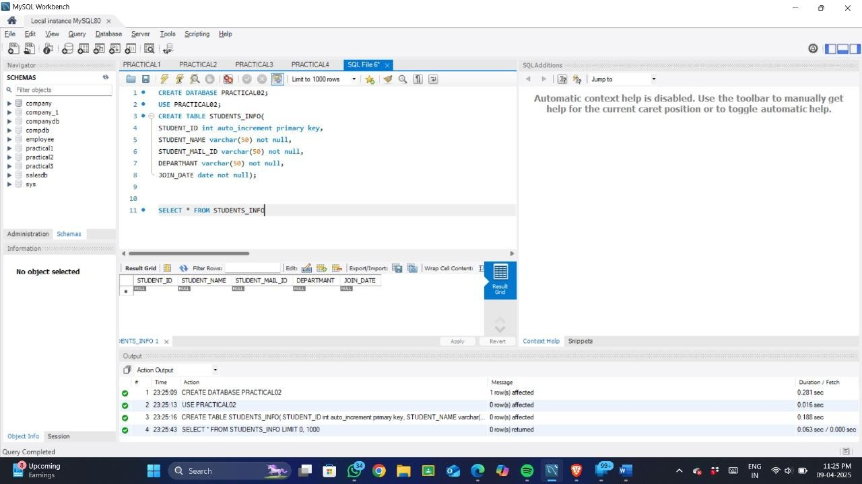

CODE FOR SOME SAMPLE DATA :-
CREATE TABLE STUDENTS_INFO (
STUDENT_ID INT AUTO_INCREMENT PRIMARY KEY,
STUDENT_NAME VARCHAR(50) NOT NULL,
STUDENT_MAIL_ID VARCHAR(50) NOT NULL,
DEPARTMANT VARCHAR(50) NOT NULL,
JOIN_DATE DATE NOT NULL
);

INSERT INTO STUDENTS_INFO (STUDENT_NAME, STUDENT_MAIL_ID, DEPARTMANT, JOIN_DATE)
VALUES
('jitendra', 'jitendrashinde24@sanjivani.edu.in', 'CSE', '2024-09-13'),
('ALEX ROY', 'alexroy@yahoo.com', 'CY', '2020-03-04'),
('ROBIN HOOD', 'robhood@google.com', 'AIML', '2024-01-12'),
('WEDNESDAY ADAM', 'wedadam@hotmail.com', 'AIDS', '2023-06-14'),
('KAILY SWIFT', 'kailyswift@example.com', 'CY', '2020-03-04');

SELECT * FROM STUDENTS_INFO;

Output:
CODE FOR UPDATE THE TABLE :-
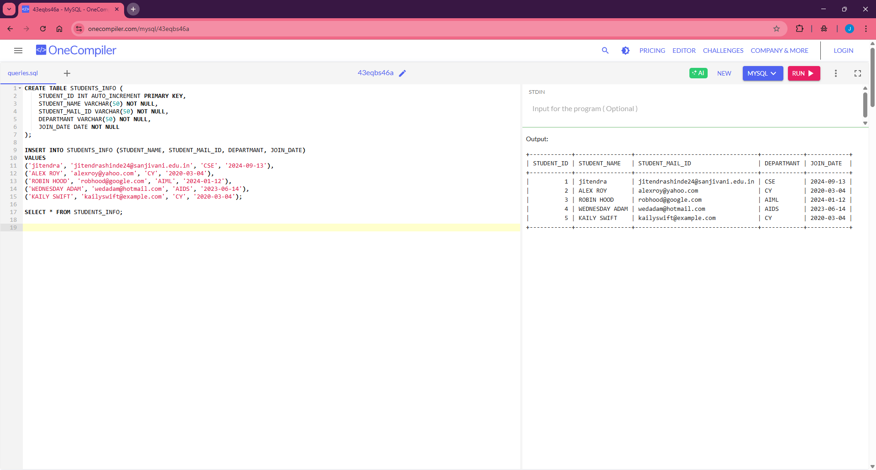

- UPDATE STUDENTS_INFO
- SET DEPARTMANT = 'BBA'
- WHERE STUDENT_ID = 5;
- SELECT * FROM STUDENTS_INFO

OUTPUT :-

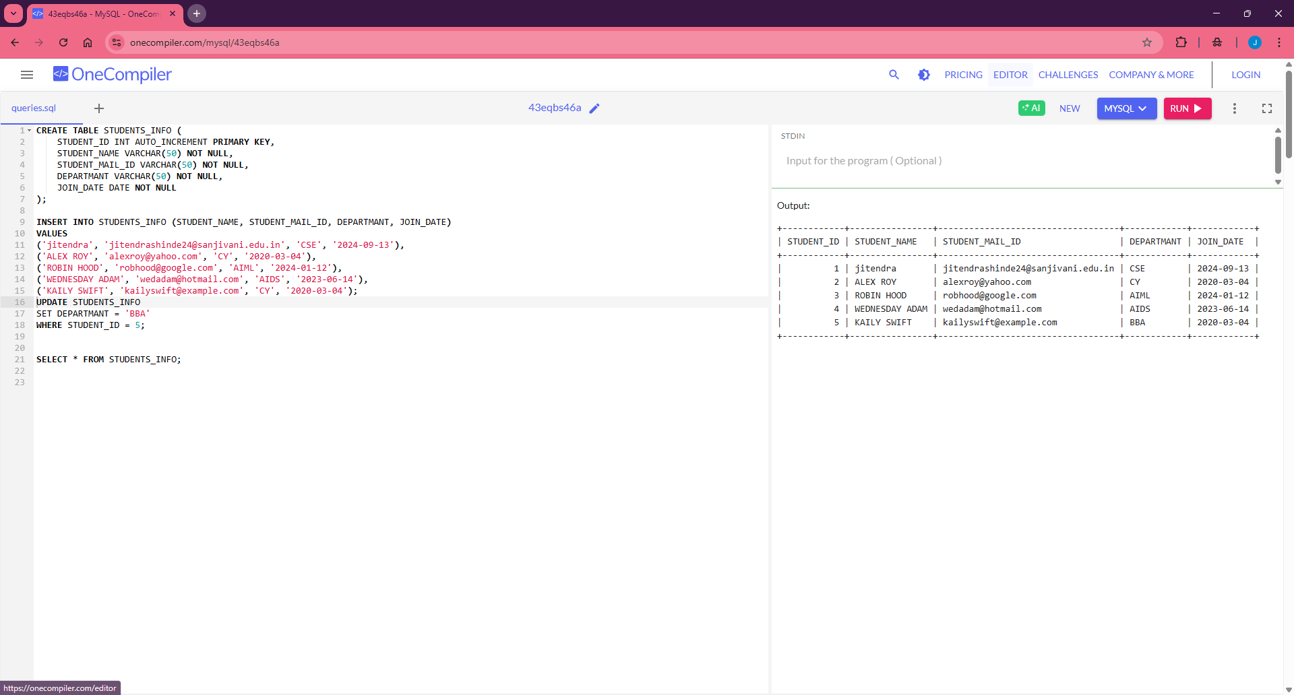

- CODE FOR DELETE THE RECORD FROM THE TABLE :-

DELETE FROM STUDENTS_INFO
WHERE STUDENT_ID = 3;
SELECT * FROM STUDENTS_INFO

OUTPUT :-
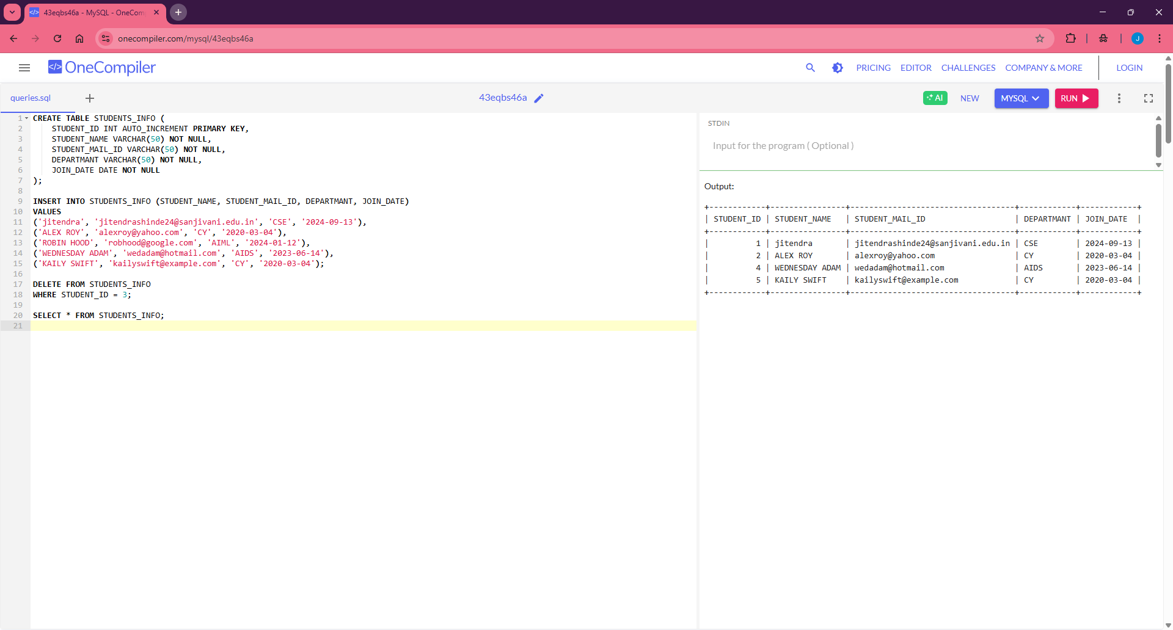

Lab File – Practical 3

AIM :- Create a table with columns for EmployeeID, Name, Salary, JoiningDate, and ActiveStatus using different data types. Insert sample data and perform queries to manipulate and retrieve data.

- CODE FOR CREATION OF TABLE :-
CREATE DATABASE PRACTICAll3;
USE PRACTICAll3;
CREATE TABLE Employees (
EmployeeID INT PRIMARY KEY,
Name VARCHAR(100),
Salary DECIMAL(10, 2),
JoiningDate DATE, ActiveStatus BOOLEAN); select*FROM Employees

Output:

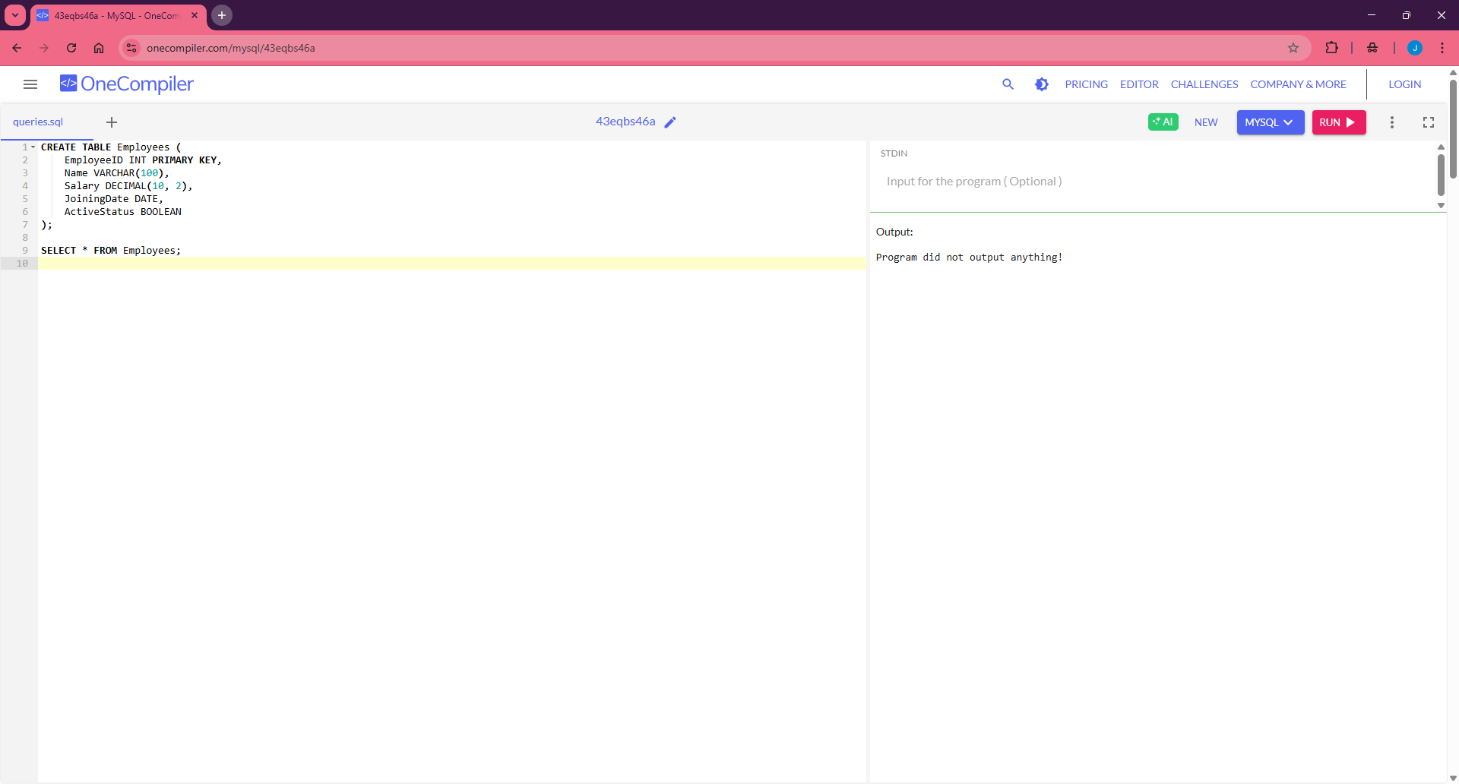

CODE FOR INSERTION OF SAMPLE DATA :-

INSERT INTO Employees (EmployeeID, Name, Salary, JoiningDate, ActiveStatus)
VALUES
(101, 'jitendra shinde', '85000.00', '2023-02-18', TRUE),
(102, 'Avery Knight', 55000.00, '2020-06-15', FALSE),
(103, 'Lena Brooks', 62000.50, '2019-03-10', TRUE),
(104, 'Kai Thornton', 48000.75, '2021-01-25', FALSE),
(105, 'Zane Holloway', 75000.00, '2018-11-01', TRUE),
(106, 'Nova Chandler', 51000.00, '2022-08-20', FALSE);

SELECT * FROM Employees

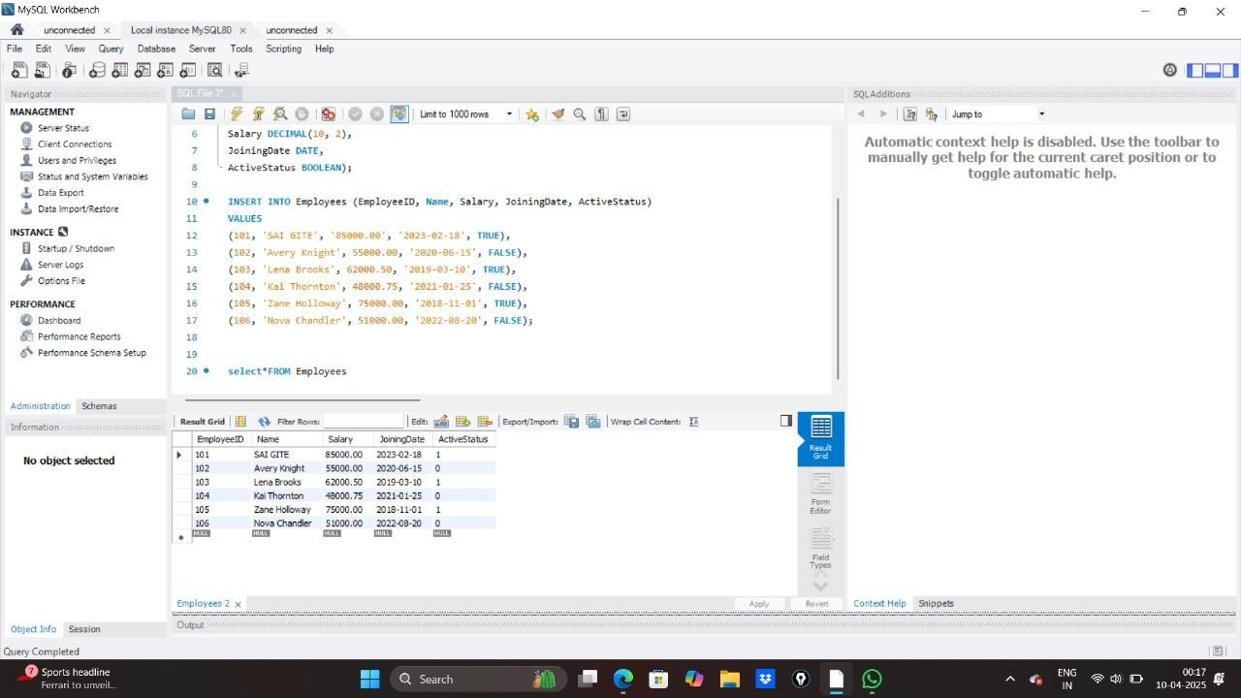

CODE FOR PERFORMING QUERIES TO MANIPULATE AND RETRIEVE DATA :-

- SELECT * FROM Employees • OUTPUT :-


- SELECT * FROM Employees WHERE Salary > 60000 ;
OUTPUT :-
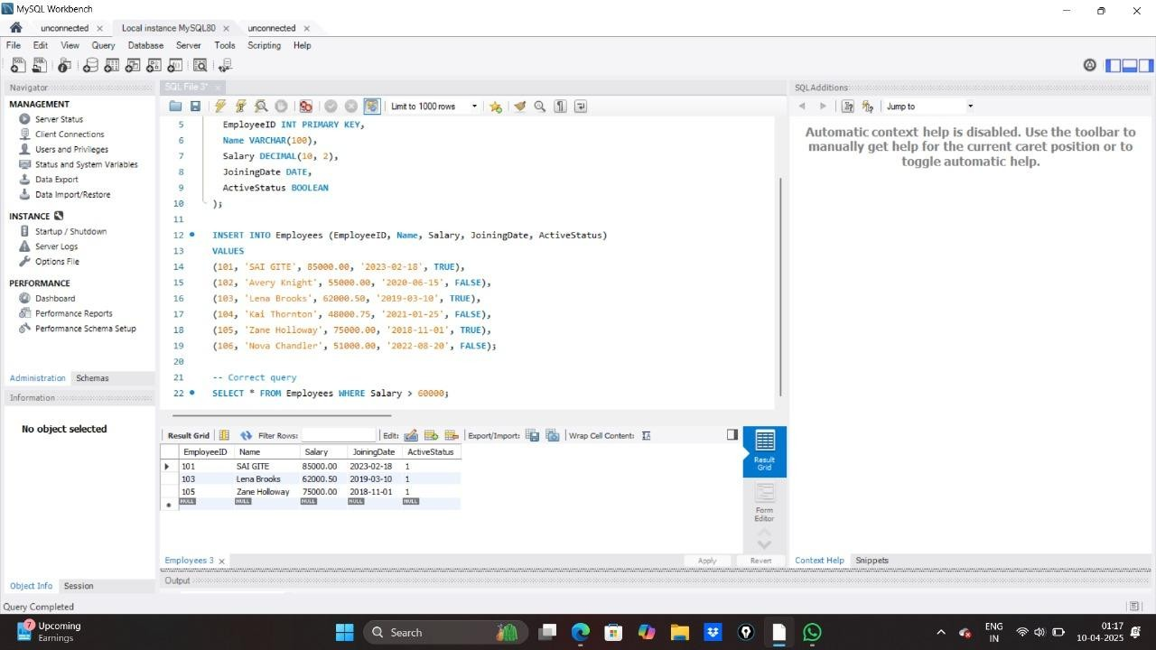

5.UPDATE Employees
SET ActiveStatus = TRUE
WHERE EmployeeID = 106;
SELECT Name, ActiveStatus
FROM EMPLOYEES
WHERE EmployeeID = 106;
• OUTPUT :-
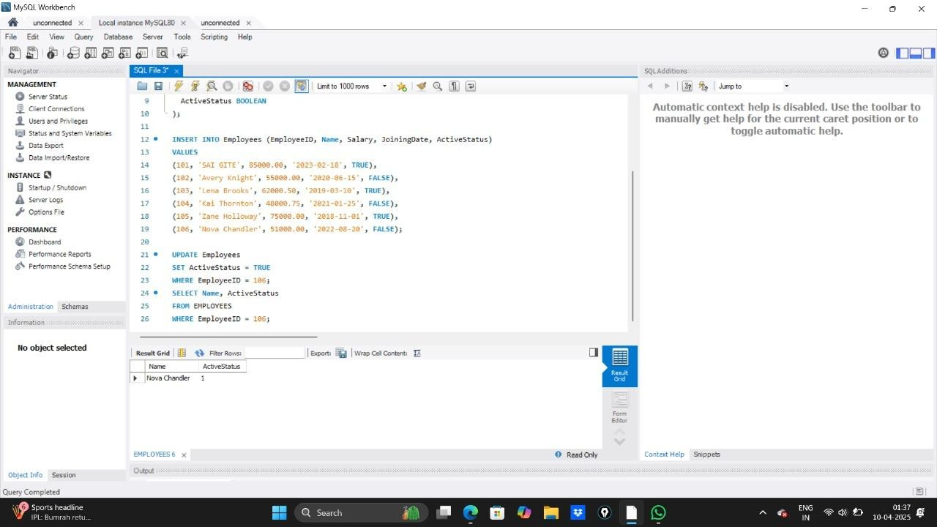

Lab File – Practical 4

Aim: Create a table to store employee information with constraints like Primary Key,Foreign Key, and Unique.

Code :
CREATE TABLE Department (
DeptID INT PRIMARY KEY,
DeptName VARCHAR(50) UNIQUE
);
-- Create Employee Table
CREATE TABLE Employee (
EmpID INT PRIMARY KEY,
Name VARCHAR(100) NOT NULL,
Email VARCHAR(100) UNIQUE,
Salary DECIMAL(10,2) CHECK (Salary > 0),
DeptID INT,
FOREIGN KEY (DeptID) REFERENCES Department(DeptID)
);
INSERT INTO Department (DeptID, DeptName) VALUES (1, 'HR');
INSERT INTO Department (DeptID, DeptName) VALUES (2, 'IT');

INSERT INTO Employee (EmpID, Name, Email, Salary, DeptID)
VALUES (101, ‘jitendra’, 'jitendra.s@example.com', 50000.00, 1);

INSERT INTO Employee (EmpID, Name, Email, Salary, DeptID)
VALUES (102, 'PRATIk', 'bob@example.com', 60000.00, 2);

INSERT INTO Employee (EmpID, Name, Email, Salary, DeptID)
VALUES (103, 'Charlie', 'charlie@example.com', 55000.00, 1);

INSERT INTO Employee (EmpID, Name, Email, Salary, DeptID)
VALUES (104, 'David', 'david@example.com', 45000.00, 2);

INSERT INTO Employee (EmpID, Name, Email, Salary, DeptID)
VALUES (105, 'Frank', 'frank@example.com', 40000.00, 1);

SELECT * FROM Employee;
SELECT * FROM Department;

Output:

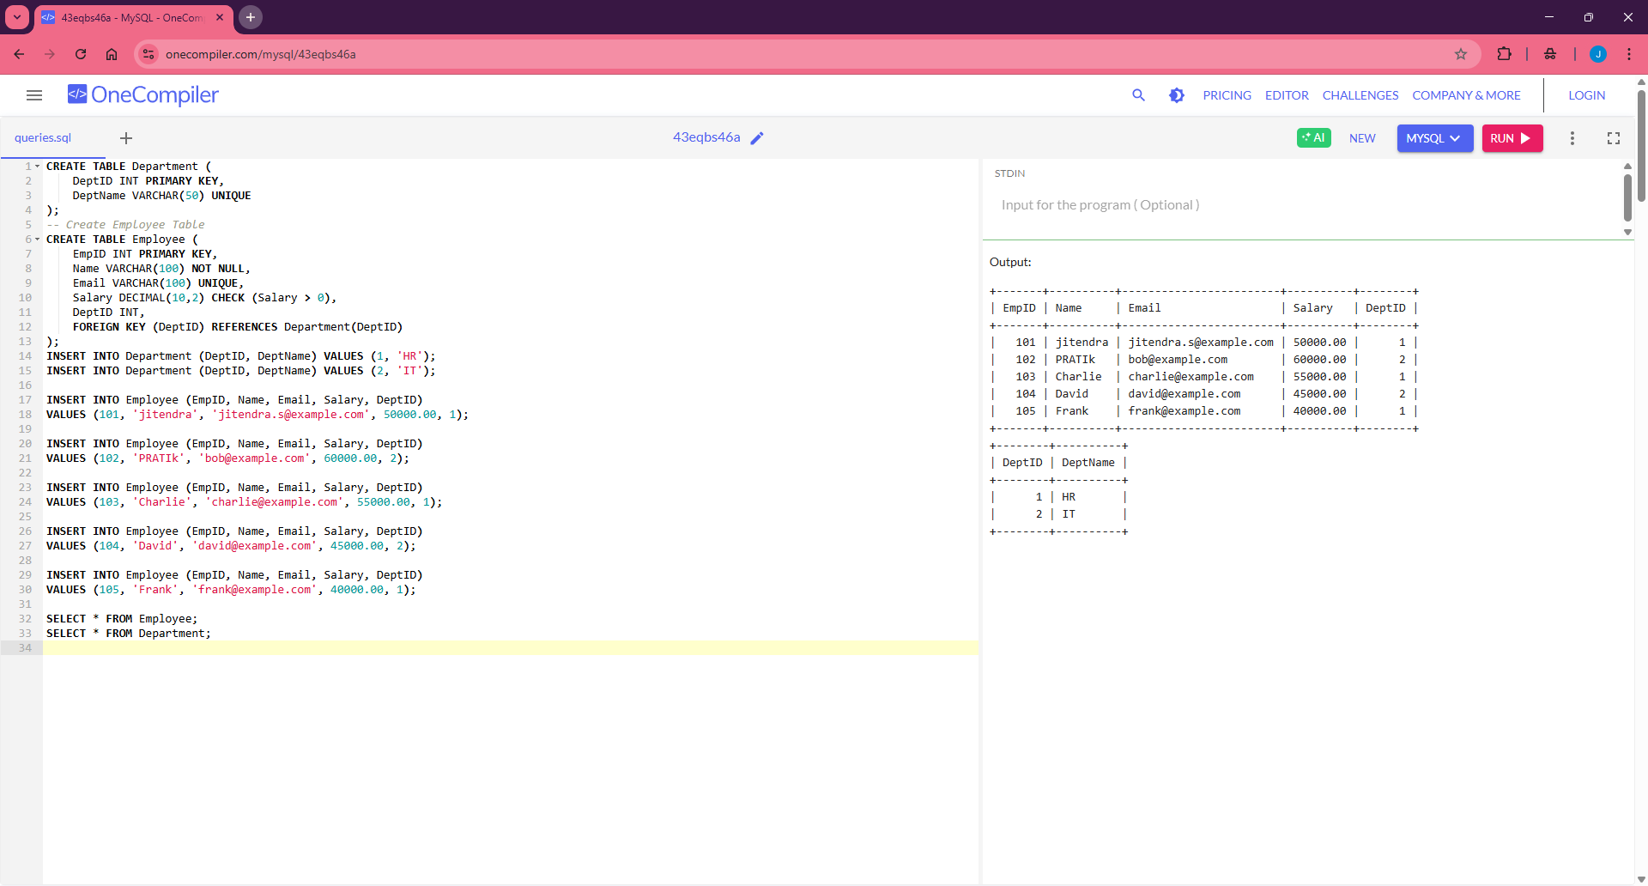

Lab File – Practical 5

Aim: Create a table for Customer details with various integrity constraints like NOT NULL, CHECK, and DEFAULT. Insert valid and invalid data to test these constraints and ensure data integrity.

Code :
CREATE TABLE Department (
DeptID INT PRIMARY KEY,
DeptName VARCHAR(50) UNIQUE
);
-- Create Employee Table
CREATE TABLE Employee (
EmpID INT PRIMARY KEY,
Name VARCHAR(100) NOT NULL,
Email VARCHAR(100) UNIQUE,
Salary DECIMAL(10,2) CHECK (Salary > 0),
DeptID INT,
FOREIGN KEY (DeptID) REFERENCES Department(DeptID)
);
INSERT INTO Department (DeptID, DeptName) VALUES (1, 'HR');
INSERT INTO Department (DeptID, DeptName) VALUES (2, 'IT');

INSERT INTO Employee (EmpID, Name, Email, Salary, DeptID)
VALUES (101, 'jitendra', ‘jitendra.s @example.com', 50000.00, 1);

INSERT INTO Employee (EmpID, Name, Email, Salary, DeptID)
VALUES (102, 'PRATIk', 'bob@example.com', 60000.00, 2);

INSERT INTO Employee (EmpID, Name, Email, Salary, DeptID) VALUES (103, 'Charlie', 'charlie@example.com', 55000.00, 1); INSERT INTO Employee (EmpID, Name, Email, Salary, DeptID)
VALUES (104, 'David', 'david@example.com', 45000.00, 2);

INSERT INTO Employee (EmpID, Name, Email, Salary, DeptID)
VALUES (105, 'Frank', 'frank@example.com', 40000.00, 1);

SELECT * FROM Employee; SELECT * FROM Department;
Output :

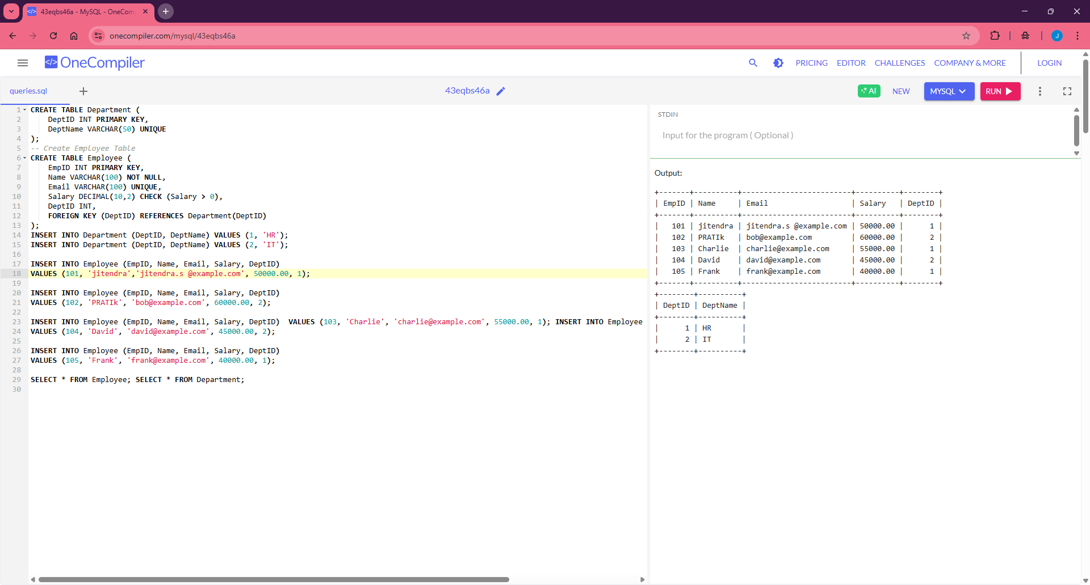

Lab File – Practical 6 :

Aim: Use DDL commands to create tables and DML commands to insert, update, and delete data. Write SELECT queries to retrieve and verify data changes.

Code :
CREATE TABLE Employees (
EmployeeID INT PRIMARY KEY,
FirstName VARCHAR(50),
LastName VARCHAR(50),
Age INT,
Department VARCHAR(50),
Salary DECIMAL(10, 2)
);

INSERT INTO Employees (EmployeeID, FirstName, LastName, Age, Department, Salary)
VALUES (1, 'jitendra', 'shinde', 28, 'HR', 50000.00);

INSERT INTO Employees (EmployeeID, FirstName, LastName, Age, Department, Salary)
VALUES (2, 'Jane', 'Smith', 35, 'IT', 65000.00);

INSERT INTO Employees (EmployeeID, FirstName, LastName, Age, Department, Salary)
VALUES (3, 'Michael', 'Johnson', 40, 'Finance', 75000.00);

UPDATE Employees
SET Salary = 70000.00
WHERE EmployeeID = 2;

UPDATE Employees
SET FirstName = 'jitendra', LastName = 'shinde', Salary = 75000.00
WHERE EmployeeID = 2;

UPDATE Employees
SET FirstName = 'Michael', LastName = 'Brown', Age = 45, Department = 'Management', Salary = 80000.00
WHERE EmployeeID = 3;

UPDATE Employees
SET Salary = Salary * 1.10
WHERE Department = 'HR';

UPDATE Employees
SET Salary = Salary + 5000
WHERE Salary = (
SELECT max_sal FROM (
SELECT MAX(Salary) AS max_sal FROM Employees
) AS temp
);

UPDATE Employees
SET Salary = CASE
WHEN Department = 'HR' THEN Salary * 1.05
WHEN Department = 'IT' THEN Salary * 1.08
WHEN Department = 'Finance' THEN Salary * 1.10
ELSE Salary
END;

DELETE FROM Employees WHERE EmployeeID = 1;

SELECT * FROM Employees;

SELECT * FROM Employees WHERE EmployeeID = 2;

SELECT * FROM Employees WHERE EmployeeID = 1;

Output:
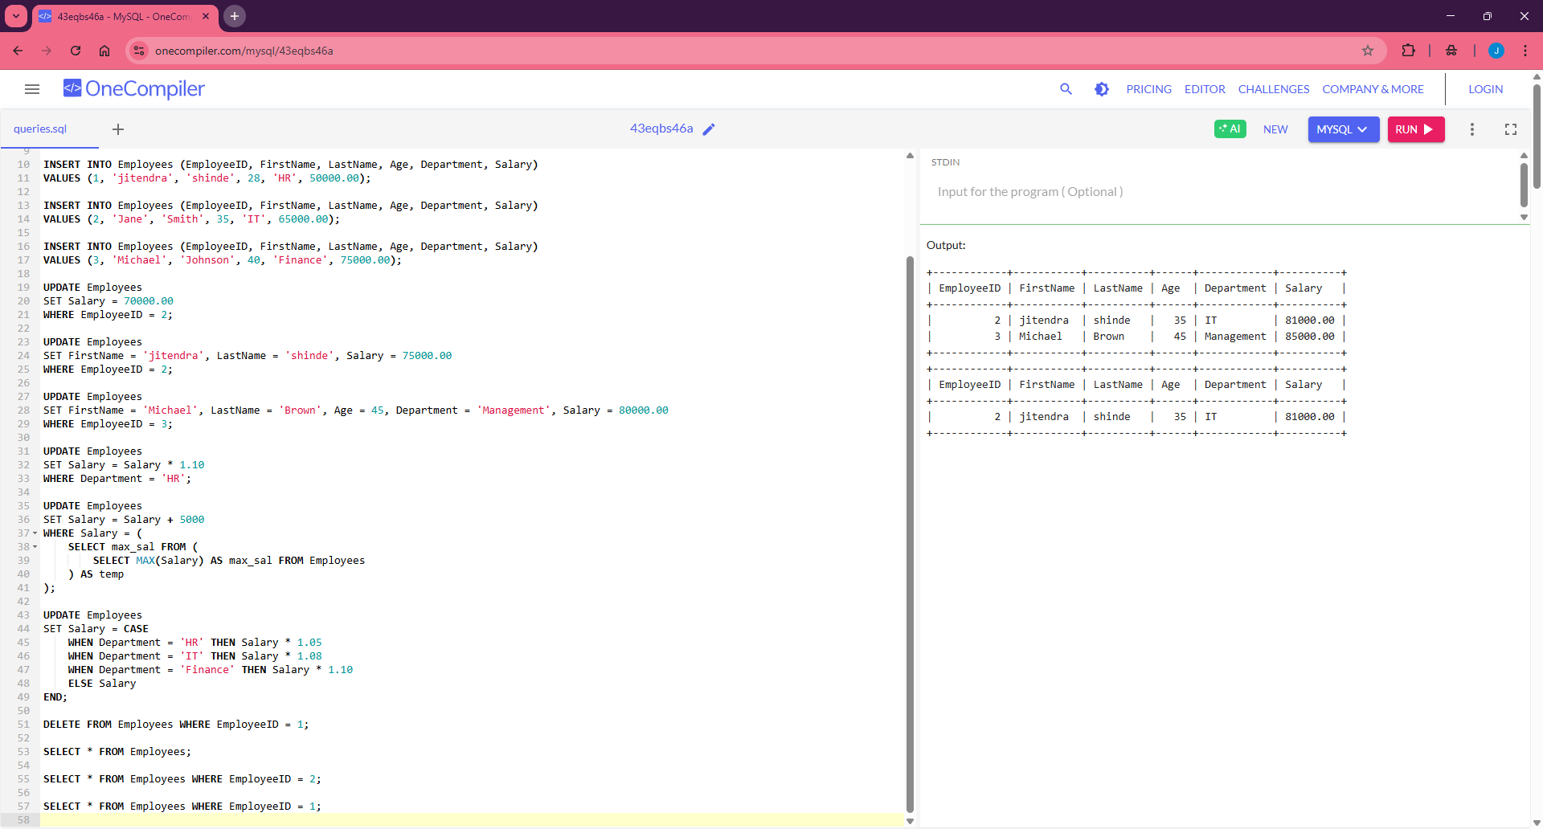

Lab File – Practical 7

Aim : Create a Sales table and use aggregate functions like COUNT,SUM, AVG, MIN, and MAX to summarize sales data and calculate statistics.

Code :
-- Create the Sales table
CREATE TABLE Sales (
SaleID INT PRIMARY KEY AUTO_INCREMENT,
Product VARCHAR(50),
Quantity INT,
Price DECIMAL(10,2),
SaleDate DATE
);

-- Insert valid sales data
INSERT INTO Sales (Product, Quantity, Price, SaleDate) VALUES
('Laptop', 2, 75000.00, '2025-02-01'),
('Mobile', 5, 20000.00, '2025-02-02'),
('Tablet', 3, 30000.00, '2025-02-03'),
('Laptop', 1, 78000.00, '2025-02-04'),
('Mobile', 4, 22000.00, '2025-02-05'),
('Tablet', 2, 32000.00, '2025-02-06');

-- COUNT queries
SELECT COUNT(*) AS Total_Sales FROM Sales;
SELECT COUNT(DISTINCT Product) AS Unique_Products FROM Sales;
SELECT Product, COUNT(*) AS Sales_Count FROM Sales GROUP BY Product;
SELECT SaleDate, COUNT(*) AS Sales_Per_Day FROM Sales GROUP BY SaleDate;
SELECT COUNT(*) AS High_Quantity_Sales FROM Sales WHERE Quantity > 2;
SELECT COUNT(*) AS Sales_This_Month
FROM Sales
WHERE MONTH(SaleDate) = MONTH(CURRENT_DATE)
AND YEAR(SaleDate) = YEAR(CURRENT_DATE);
SELECT COUNT(*) AS High_Value_Sales FROM Sales WHERE (Quantity * Price) > 50000;
SELECT Product, COUNT(*) AS High_Value_Transactions
FROM Sales
WHERE (Quantity * Price) > 40000
GROUP BY Product;
SELECT COUNT(*) AS Sales_After_Date FROM Sales WHERE SaleDate > '2025-02-03';

-- SUM queries
SELECT SUM(Quantity * Price) AS Total_Revenue FROM Sales;
SELECT SUM(Quantity) AS Total_Quantity_Sold FROM Sales;
SELECT Product, SUM(Quantity * Price) AS Revenue_Per_Product FROM Sales GROUP BY Product;
SELECT SaleDate, SUM(Quantity * Price) AS Revenue_Per_Day FROM Sales GROUP BY SaleDate;
SELECT SUM(Quantity * Price) AS Revenue_This_Month
FROM Sales
WHERE MONTH(SaleDate) = MONTH(CURRENT_DATE)
AND YEAR(SaleDate) = YEAR(CURRENT_DATE);
SELECT SUM(Quantity * Price) AS High_Quantity_Revenue FROM Sales WHERE Quantity > 2;
SELECT SUM(Quantity * Price) AS Revenue_After_Date FROM Sales WHERE SaleDate > '2025-02-03';
SELECT Product, SUM(Quantity * Price) AS High_Value_Revenue
FROM Sales
WHERE (Quantity * Price) > 40000
GROUP BY Product;

-- AVG queries
SELECT AVG(Price) AS Average_Price FROM Sales;
SELECT AVG(Quantity) AS Average_Quantity_Sold FROM Sales;
SELECT AVG(Quantity * Price) AS Average_Revenue_Per_Transaction FROM Sales;
SELECT Product, AVG(Price) AS Average_Price_Per_Product FROM Sales GROUP BY Product;
SELECT Product, AVG(Quantity * Price) AS Average_Revenue_Per_Product FROM Sales GROUP BY Product;
SELECT Product, AVG(Quantity) AS Average_Quantity_Per_Product FROM Sales GROUP BY Product;
SELECT SaleDate, AVG(Quantity * Price) AS Average_Revenue_Per_Day FROM Sales GROUP BY SaleDate;
SELECT AVG(Quantity * Price) AS Average_Revenue_This_Month
FROM Sales
WHERE MONTH(SaleDate) = MONTH(CURRENT_DATE)
AND YEAR(SaleDate) = YEAR(CURRENT_DATE);
SELECT AVG(Price) AS Avg_Price_High_Quantity_Sales FROM Sales WHERE Quantity > 2;
SELECT AVG(Quantity * Price) AS Average_Revenue_After_Date FROM Sales WHERE SaleDate > '2025-02-03'; -- MIN and MAX queries
SELECT MIN(Price) AS Min_Price, MAX(Price) AS Max_Price FROM Sales;
SELECT MIN(Quantity) AS Min_Quantity_Sold, MAX(Quantity) AS Max_Quantity_Sold FROM Sales;
SELECT MIN(Quantity * Price) AS Min_Revenue, MAX(Quantity * Price) AS Max_Revenue FROM Sales;
SELECT Product, MIN(Price) AS Min_Price_Per_Product, MAX(Price) AS Max_Price_Per_Product FROM Sales GROUP BY Product;
SELECT Product, MIN(Quantity * Price) AS Min_Revenue_Per_Product, MAX(Quantity * Price) AS Max_Revenue_Per_Product FROM Sales GROUP BY Product;
SELECT Product, MIN(Quantity) AS Min_Quantity_Per_Product, MAX(Quantity) AS Max_Quantity_Per_Product FROM Sales GROUP BY Product;
SELECT SaleDate, MIN(Quantity * Price) AS Min_Revenue_Per_Day, MAX(Quantity * Price) AS Max_Revenue_Per_Day FROM Sales GROUP BY SaleDate;
SELECT MIN(Quantity * Price) AS Min_Revenue_This_Month, MAX(Quantity * Price) AS
Max_Revenue_This_Month
FROM Sales
WHERE MONTH(SaleDate) = MONTH(CURRENT_DATE)
AND YEAR(SaleDate) = YEAR(CURRENT_DATE);
SELECT MIN(Price) AS Min_Price_High_Quantity_Sales, MAX(Price) AS Max_Price_High_Quantity_Sales FROM Sales WHERE Quantity > 2;
SELECT MIN(Quantity * Price) AS Min_Revenue_After_Date, MAX(Quantity * Price) AS
Max_Revenue_After_Date FROM Sales WHERE SaleDate > '2025-02-03';

Output :

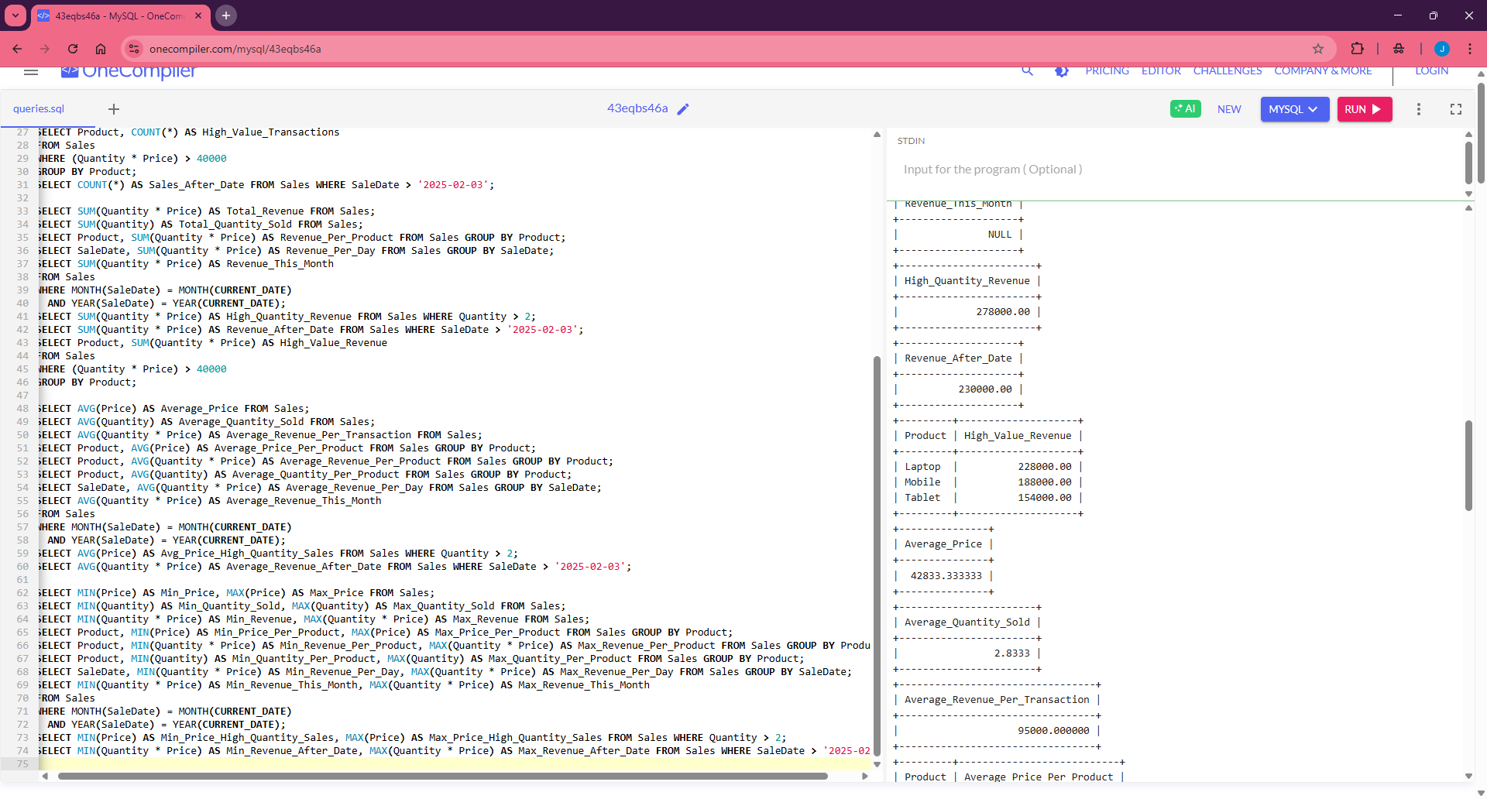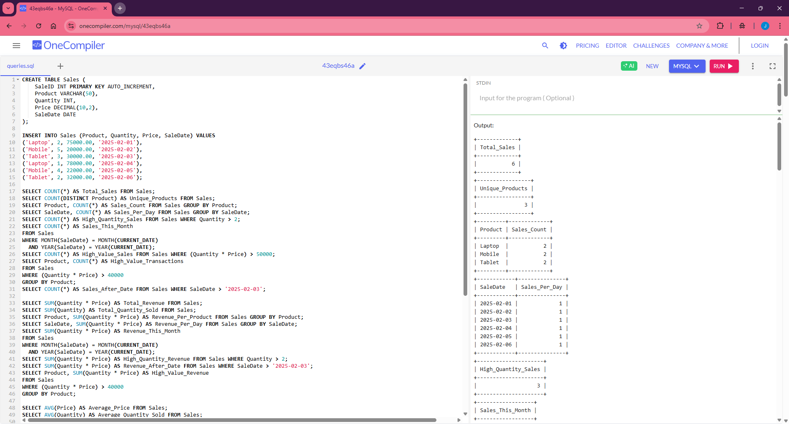

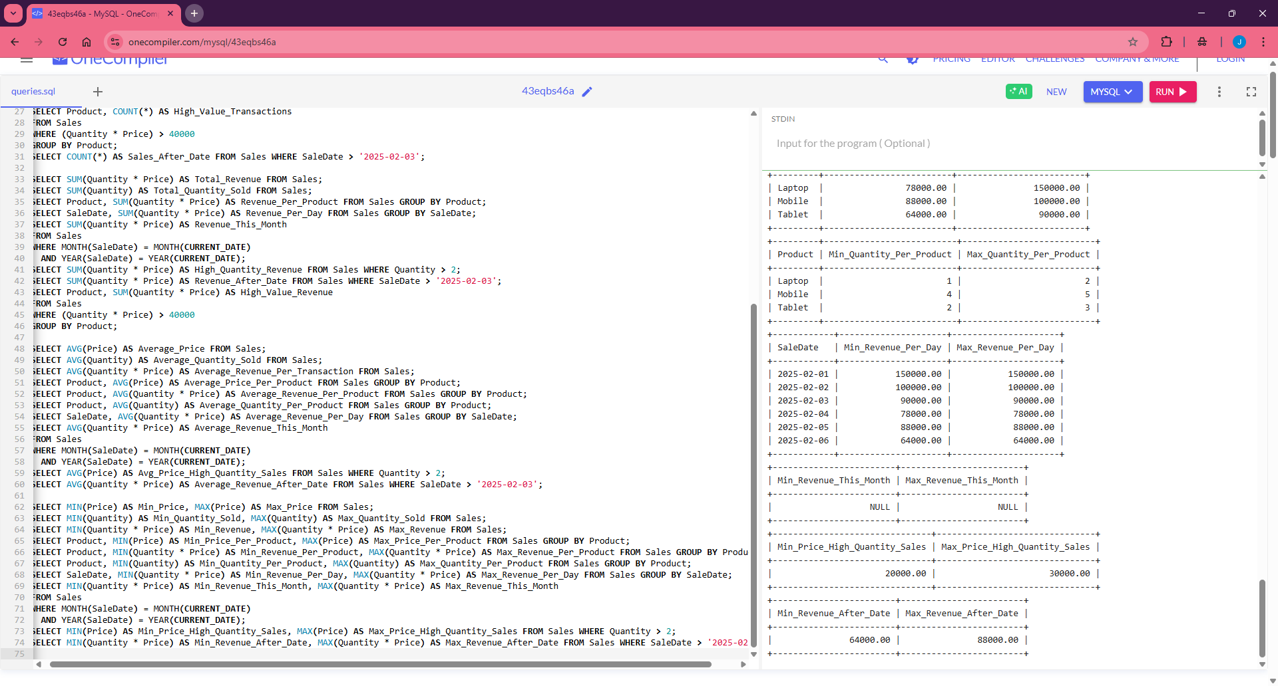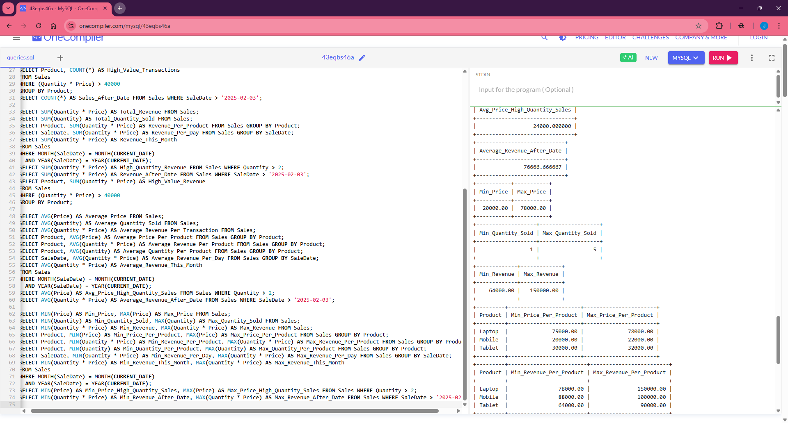

Lab File – Practical 8 :

Aim : Given Customers and Orders tables, write SQL queries to perform INNER JOIN, LEFT JOIN, and RIGHT JOIN to retrieve combined data for customer orders.

Code :
CREATE TABLE Customers (
customer_id INT PRIMARY KEY,
customer_name VARCHAR(100) NOT NULL
);

CREATE TABLE Orders (
order_id INT PRIMARY KEY,
order_date DATE NOT NULL,
customer_id INT,
FOREIGN KEY (customer_id) REFERENCES Customers(customer_id)
);

INSERT INTO Customers (customer_id, customer_name) VALUES
(1, 'jitendra'),
(2, 'Bob'),
(3, 'Charlie'),
(4, 'David');

INSERT INTO Orders (order_id, order_date, customer_id) VALUES
(101, '2024-01-01', 1),
(102, '2024-01-02', 2),
(103, '2024-01-03', 4);

SELECT * FROM Customers;

SELECT * FROM Orders;

SELECT
c.customer_id,
c.customer_name,
o.order_id,
o.order_date
FROM
Customers c
INNER JOIN
Orders o
ON
c.customer_id = o.customer_id;

SELECT
c.customer_id,
c.customer_name,
o.order_id,
o.order_date
FROM
Customers c
LEFT JOIN
Orders o
ON
c.customer_id = o.customer_id;

SELECT
c.customer_id,
c.customer_name,
o.order_id,
o.order_date
FROM
Customers c
RIGHT JOIN
Orders o
ON
c.customer_id = o.customer_id;

OUTPUT:
